**SYSTEM PROTOTYPE**

**Project Description**

Snak is a food-delivery app aimed at the Filipino audience. It is an app that allows for the delivery of quick snacks, imported or local, from warehouses to local vendors on the street, promoting local products and allowing these products to become easily accessible to the general public and especially customers who cannot go outside to buy from their favorite local vendors. Snak will allow customers to order snacks from different vendors and different modes of payment to cater to each customer.

**Requirement Summary**

|  |  |  |
| --- | --- | --- |
| **MINIMUM REQUIREMENTS** | Processor Cores | Single Core |
| OS | Android 7.0 (Nougat) |
| RAM | 2.0 GB |
| **RECOMMENDED REQUIREMENTS** | Processor Core | Quad Core |
| OS | Android 8 (Oreo) and above |
| RAM | 4.0 GB |
| **OTHER REQUIREMENTS** | Permissions | Location |
| Notifications and Storage |
| Messaging and Phone Calls |

The application is not heavy, however, the lowest the application will settle for is Android 7.0 as the market for this android version is quite small, but still existing. Aside from that, the minimum requirements are very low since the application is not demanding.

**Prototype Description**

The prototype was made using Canva, contained within this link: <https://www.canva.com/design/DAGJ4tfI6mk/xajrMcx_e14VawdiCP-fVg/edit?utm_content=DAGJ4tfI6mk&utm_campaign=designshare&utm_medium=link2&utm_source=sharebutton>.

**Problem Scenario**

Rio is a disabled university student. He is taken care of by his sister who works a 9-5 job. While Rio can manage just fine, there are occasions where he wishes to go outside to grab a quick snack; in particular, he is craving *maruya* from a vendor a few streets away from him, which he often passes by on his way back from university. Unfortunately, going on wheelchair is too much of a hassle and he is alone right now, and many food delivery apps currently do not have this specific vendor in their shops. Thus, Rio chooses to use Snak so the maruya from his favorite local vendor can be delivered right to his door. With this, he is able to get his favorite snack, support the local vendor, and save time and effort he would have used to go all the way to his favorite vendor.

**Prototype Design**

Below are the following elements in detail.

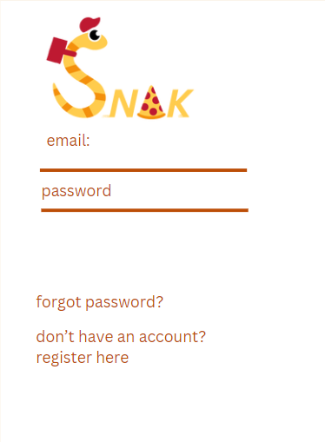

Users begin at the login screen, with options for if the user forgot their password or if they still do not have an account.

Upon finishing authentication, users are led to the home page where they can search for a shop or click on the delivery button. The cart, which stores pending orders waiting to be taken out is located on the bottom right of the screen. Within the search bar section on the top, there is a heart icon which contains the user’s favorites which they can add to later, and a settings icon which will contain settings. Below the delivery button is a vouchers section which users can claim, and this section can be scrolled horizontally to view more. Underneath is the top picks which can be scrolled like the vouchers section and contains highest rated restaurants.

This screen appears upon clicking the delivery button. If the search function from the home page was used, the most accurate search will be displayed first. Underneath the search bar are tags people can filter their search results by, and more are contained within the settings option right next to the “Local” tag. Each vendor image has a heart to the top right, indicating it can be favorited and added to the favorites list in the home page. Vendors with the “Top Vendor” label will appear in the Top Picks section in the home page. Vendors also have short descriptions of their products and discount and offer tags to entice customers.

When a user clicks on a vendor, the vendor’s page will open. Atop is the banner, vendor name, ratings and reviews, and distance from the customer. Underneath, the vendors have tags with which users can filter results by. Each product has a heart on the top right, indicating that individual products can be favorited as well.

When confirming the order, users are taken to the check-out page where they can check details such as their address, payment method, order summary, delivery fee, and appliable vouchers. Users can change these settings by clicking on the arrow. The total is shown at the bottom, accounting for discounts, delivery fee, and vouchers. When clicking confirm, the order will be delivered.

**Rationale**

The goal of Snak is to make local snacks and warehouse chips easier to buy and access for the Filipino people, disabled, elderly, or people who just can’t go outside to get their favorite snack. The project seeks to promote our local vendors’ shops and warehouse chips by making them easily accessible and available for potential customers who are only stopped from going there due to their circumstances. As such, Snak aims to bridge the gap between the willing customers and the vendors.

**Changes in Requirements**

During the designing process of our project, Snak initially was supposed to have a mixed deals with snacks and products coming from different vendors. However, this felt quite difficult to achieve, especially for our drivers who would have to drive to each vendor to pick up the products part of the deal. The idea was discarded to ensure the simplicity of Snak and proper treatment of its drivers.

**Initial Evaluation Plan**

For evaluation, the project will be tested for its overall ease of use, overall aesthetic, and the aesthetic of each individual prototype section. This is to ensure that while it is easy to use and navigate in for all, that the design will live up to the users’ expectations as something clean, simple, and easy to look at.